**Node.Js-App Deployment using Jenkins Pipeline**

1. **Prerequisites**

Before starting, make sure you have:

* Jenkins installed and running
* Node.js and npm installed on the build server
* **Git** installed (for pulling source cod)
* SSH Agent
* Github plugin (webhook)-(for pushing)
* Piipeline plugin

1. **Install dependencies:**

npm install

1. **After restarting the Jenkins server launched a node-app-server:**

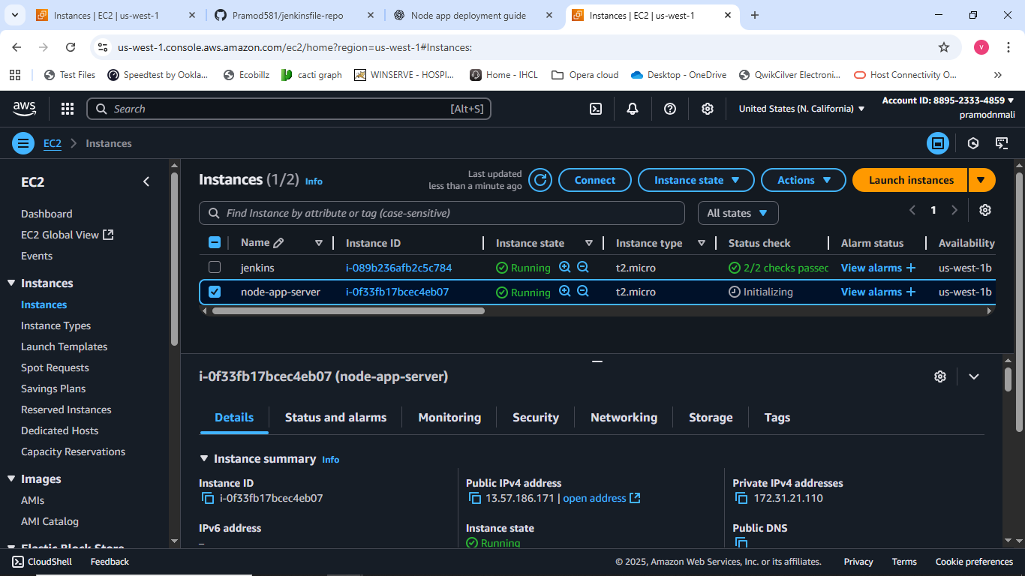

**Installed plugins: SSH agent and Github**

1. **Set credentials for ssh: By saving private key named as node-app-key.**

1. **Pushed the below mentioned code to github by creating a repository as jenkinsfile**

pipeline {

    agent any

    environment {

        SERVER_IP      = ' 54.176.80.202'

        SSH_CREDENTIAL = 'node-app-key’

        REPO_URL       = '' https://github.com/Pramod581/node-js-app-CICD.git

        BRANCH         = 'main'

        REMOTE_USER    = 'ubuntu'

        REMOTE_PATH    = '/home/ubuntu/node-app'

    }

    stages {

        stage('Clone Repository') {

            steps {

                git branch: "${BRANCH}", url: "${REPO_URL}"

            }

        }

        stage('Upload Files to EC2') {

            steps {

                sshagent([SSH_CREDENTIAL]) {

                    sh """

                        ssh -o StrictHostKeyChecking=no ${REMOTE_USER}@${SERVER_IP} 'mkdir -p ${REMOTE_PATH}'

                        scp -o StrictHostKeyChecking=no -r * ${REMOTE_USER}@${SERVER_IP}:${REMOTE_PATH}/

                    """

                }

            }

        }

        stage('Install Dependencies & Start App') {

            steps {

                sshagent([SSH_CREDENTIAL]) {

                    sh """

                        ssh -o StrictHostKeyChecking=no ${REMOTE_USER}@${SERVER_IP} '

                            cd ${REMOTE_PATH} &&

                            npm install &&

                            pm2 start app.js --name node-app || pm2 restart node-app

                        '

                    """

                }

            }

        }

    }

    post {

        success {

            echo '✅ Application deployed successfully!'

        }

        failure {

            echo '❌ Deployment failed.'

        }

    }

}

**Jenkins Pipeline Setup:**

### **Create a Jenkins Pipeline Job**

* Open Jenkins dashboard → **New Item** → **Pipeline**.
* Name it: node-app-deployment.

### **Connect GitHub Repository**

* In the **Pipeline** section, choose:
  + **Definition:** "Pipeline script from SCM"
  + **SCM:** Git
  + Provide repository URL: https://github.com/<your-username>/<your-repo>.git
  + Set branch: main

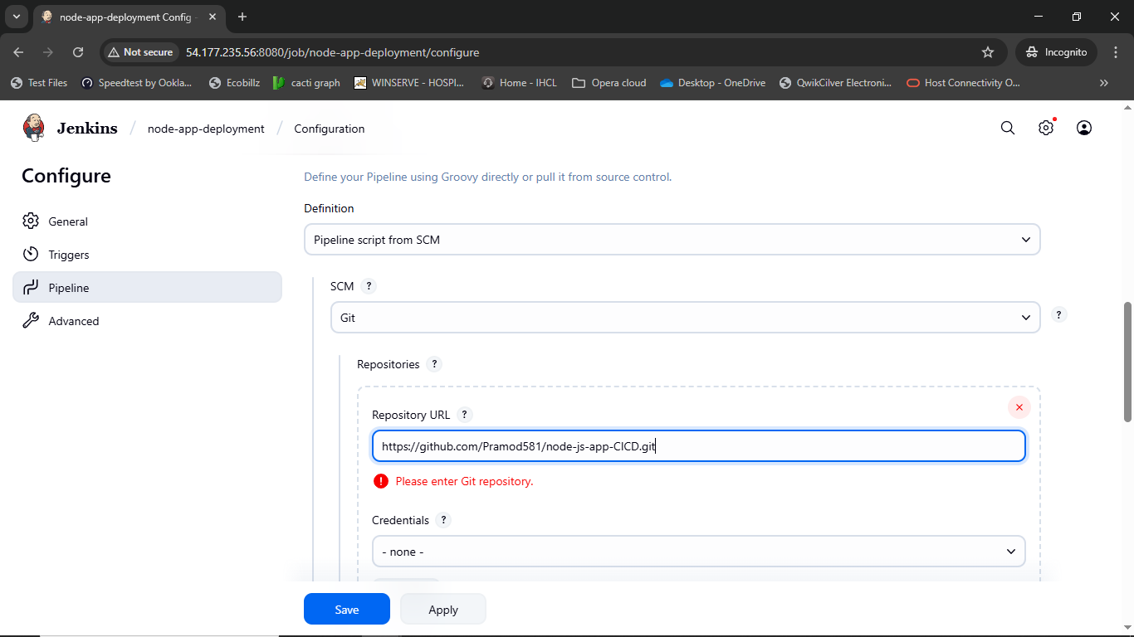

### **Jenkinsfile:**

This repository includes a Jenkinsfile which defines the pipeline stages: code mentioned in steps 5.

## **Running the Pipeline**

1. Push code changes to GitHub.
2. Jenkins automatically detects changes (if webhook is configured) or manually trigger the pipeline.
3. The pipeline executes in the following stages:
   * **Checkout** → Pulls latest code
   * **Install Dependencies** → Installs npm packages
   * **Test** → Runs unit tests
   * **Build** → Builds the application
   * **Deploy** → Deploys the app on the server

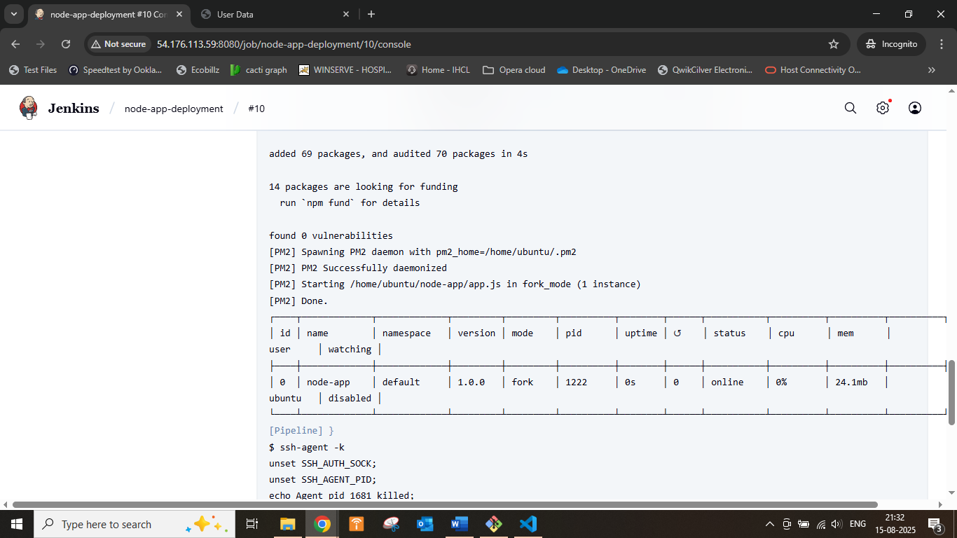

**After hitting the public ip address of server :3000**

